**Republic of the Philippines**

**UNIVERSITY OF SOUTHEASTERN PHILIPPINES**

**Information Technology Department**

**Tagum Mabini Campus**

**COMPETENCY CHECKLIST**

|  |  |  |  |  |  |  |  |  |  |
| --- | --- | --- | --- | --- | --- | --- | --- | --- | --- |
| **Day#** | **Date** |  |  | **Activities/ Tasks**  **(write these on your notebook)** | **Applied or Required** | | **Values Needed & Learned** | **Personal Rating** (Excellent=5; Very Good=4, Good=3, Fair =2; Needs Improvement=1) | **Supervisor’s Signature** (for confirmation) |
| **IN** | **OUT** | **Knowledge** | **Skills** |
| 1 | June 25, 2021 |  |  | Creating the First Task: QMS Mock Up Landing Page | Designing concepts and layouts | Leadership Skills and Organization Skills | Be Creative, Teamwork and Analytical | 5 |  |
| 2 | June 26, 2021 |  |  | Finalization on the First Task of QMS Landing Page | Critically Reviewing of Individual Designs | Leadership and Creative Skills | Teamwork, Innovative and Attention to detail | 5 |  |
| 3 |  |  |  |  |  |  |  |  |  |
| 4 |  |  |  |  |  |  |  |  |  |
| 5 |  |  |  |  |  |  |  |  |  |
| 6 |  |  |  |  |  |  |  |  |  |
| 7 |  |  |  |  |  |  |  |  |  |

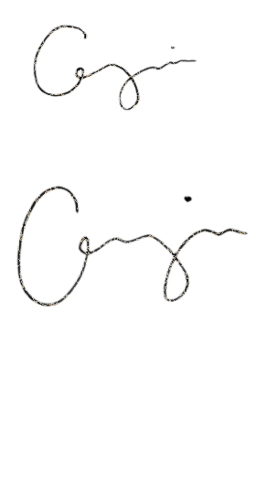I certify on the correctness of the above information. Noted by:

 Allayssa George A. Dela Cruz Mishill D. Cempron

Signature above printed name of student-trainee Signature above printed name of Supervisor